SmartCare v0.3 - Domain Model Workbook
Week 6 student resource

Requirement-to-Concept Trace
Requirement | Concept | State/behaviour | Decision
Staff can cancel an appointment | Appointment | Status changes to cancelled | Keep
System retains cancelled appointments | Appointment | Appointment history stored | Keep
Search for patient by ID | Patient | Patient record lookup | Keep
Prevent double bookings | Practitioner/Appointment | Check practitioner availability | Keep
View practitioner availability | Practitioner | Availability state | Keep
Store basic patient details | Patient | Patient attributes | Clarify
Store basic practitioner details | Practitioner | Practitioner attributes | Clarify

CRC Cards

Patient
Responsibilities | Collaborators
Store their details required for booking | Appointment
Provide information for searching | Practitioner

Practitioner
Responsibilities | Collaborators
Store their details | Appointment
Provide availability to prevent double bookings | Patient

Appointment
Responsibilities | Collaborators
Record patient, practitioner, time, and status | Patient
Maintain appointment history including cancellations | Practitioner

Appointment History
Responsibilities | Collaborators
Store past appointment states | Appointment
Provide audit information for any staff | Patient or practitioner

UML Class Diagram

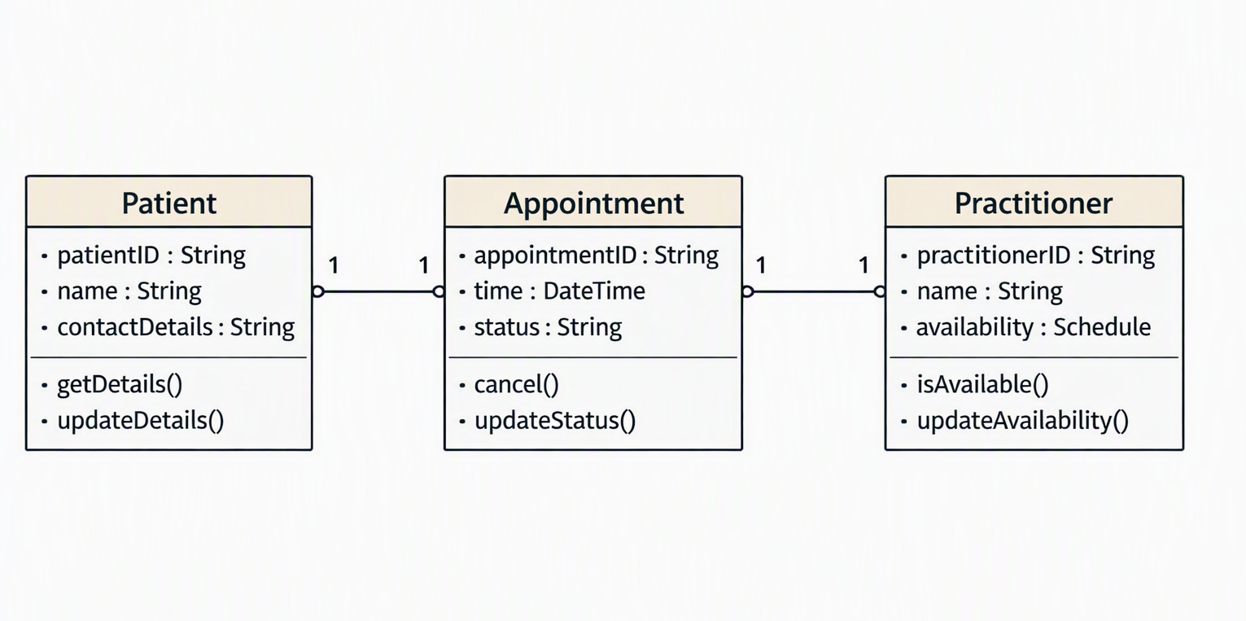

Design Rationale
Class selection:
Patient, Practitioner, and Appointment are chosen because they are the core domain concepts explicitly described in the case study. Each represents a real entity with clear data and behaviours needed to solve the clinic’s booking problems.
Responsibility allocation:
Responsibilities follow the Single Responsibility Principle.
- Patient stores patient details and supports searching.
- Practitioner stores practitioner details and availability.
- Appointment manages booking time, status, cancellation, and history.
This keeps logic local to the class that owns the relevant data.
Key relationships:
Appointments link patients and practitioners, reflecting real clinic operations. Multiplicities are based on evidence: both patients and practitioners can have multiple appointments. Inheritance is avoided because no entity is a subtype of another. A “Clinic” class is excluded because the case study does not describe any behaviours or attributes that justify its existence.

AI Design Review Record
AI suggestion | Evidence | Decision | Reason | Model change

